LOCATION RECCE:

Prepared | Yes | Date | 5th November 2017
Location details | Local park/basketball court and road outside park
Scene/Purpose of filming | To advertise the product (Adidas Deodorant)

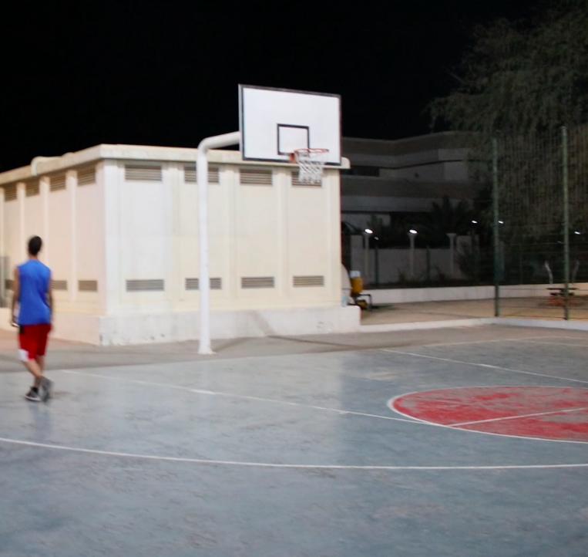 | 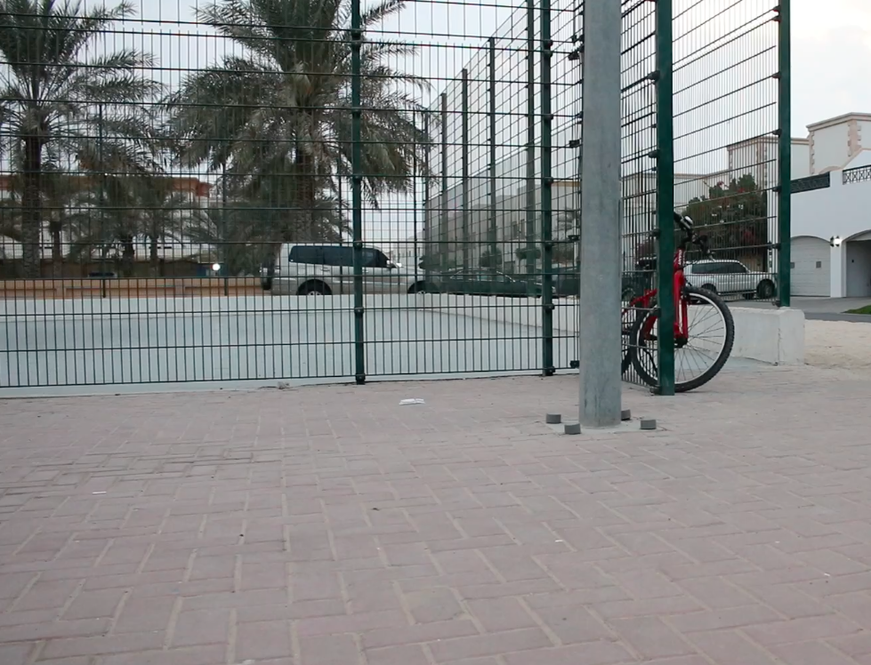

Site Contact Name |  | Site Address | Al Thanya road, Jumeirah
Contact telephone | 04 348 4999 | Point of access | Public park
Permissions | Yes | Availability | Available
Points of Interest | Basketball court and park bench | Suitability/Possible shots | Basketball court montage
Safety Issues | Cuts from falling over on the court | Electricity Supply | Lighting from the school
Safety Issues | Cuts from falling over on the court | Sunlight | Yes
Safety Issues | Cuts from falling over on the court | Windows | Yes
Safety Issues | Cuts from falling over on the court | Noise | Students talking and background noises

